Rotary Club of Kathmandu Mid-Town
Breakfast Chatter



3 November 2006 The Weekly Bulletin of Rotary Club of Kathmandu Mid-Town Bc # 18 of 2006-07

District : 3290 Web: www.rotarymidtown.org.np Club Id : 26776

NOVEMBER IS THE ROTARY FOUNDATION MONTH
Rotary International is the mother of The Rotary Foundation. In raising funds for the daughter, the mother is of vital importance and the mother has no way of spending the funds raised – that’s for the daughter to do. This shows how important cooperation is between Rotary International and The Rotary Foundation. May it so remain when we celebrate November as Rotary Foundation Month.

DG Debasish Mitra attended Club meeting on 27 October 2006
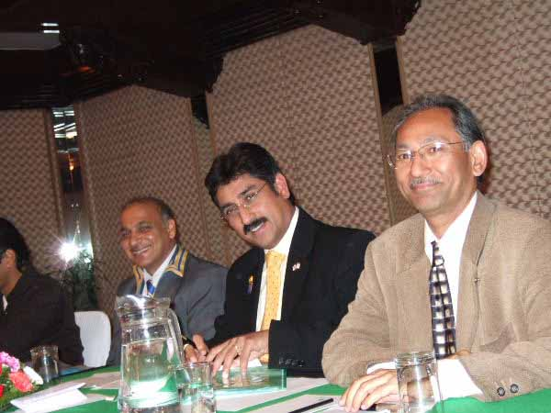
During his official visit to the club on 27 October evening DG Debasish Mitra listened to the submission of clubs reports, provided guidelines to culb officers and talked to the club members.
Club Service Director RR Shrestha
Vocational Service Director Govinda Chipalu
Community Service Director Peter Clawson, and
International Service Director Saroj Shrestha
submitted reports of their respective avenues for the year 2006-07.

Weekly Meetings and Programs :
Date | Program/Speaker | Program/Topics of Presentation
3 Nov 2006 | Dr Isabella CB Khadka | Past Reminiscences and Present Musings
10 Nov 2006 | Muna Shrestha | Waste management, responsibility of citizen
18 Nov 2006 | Charter Night Dinner meeting

Friday, 3 November :
Rtn Dr Isabella C Bassignana Khadka will be talking to the club members as the inhouse speaker. Her talk will be in two distinct parts. 'Past reminiscences' will give a glimpse into the world of semiconductor research, the field where Dr Isabella was involved for over 20 years. 'Present musings' will give a snapshot of Nepal using the geographical and census data she has been working with over the past few years since she has been in Nepal.
Transmission of information along optical fibers requires both a light source and a detector – typically lasers and photodiodes. These fundamental units are based on single crystal compound semiconductors and their derivatives. She will talk about use of high resolution x-ray diffraction as a unique tool that can be used to detect both the quality and the composition of these crystals
Demographic, social, economic, and ethnic numerical data provide a unique way to understand Nepal and its people. CBS and NLSS data are used to give a picture of Nepal and its people and to highlight trends over the past half century. She will be providing highlights of these data during her talk which would encourage 'musings' from the audience..

Good Work. Keep it up !
Kathmandu Mid-Town had provided Rs 140,000 to Rotary Club of Madras Temple City as Tsunami relief assistance in Jan 2005. The fund was used for buying bicyles for Tsunami hit school girls.
In an article titled "Rotary Wheels Lead to Better Future" by Tonya Weger in Fragile Earth Sept 2006, Kathmandu Mid-Town was featured.
"……… and Rotarians from the Rotary Club of Katmandu Mid-Town, Nepal, a country being torn apart by civil war and poverty, rallied to raise money for 95 more. In India, members of the Rotary Club of Pune Central raised money for 100 bikes."

Do you know ?
The first motto of Rotary – He profits most who serves best was approved at the RI Convention of 1911 in Oregon, USA. The RI convention of 1950 in Detroit adopted the suggestion of the Rotary Club of Minneapolis under Club President Bill Collins Service above self and combined it to read He profits most who serves best and service above self. The 1989 Council on Legislation established Service above self as the official and principal motto of Rotary, since it best explains the philosophy of unselfish volunteer service.
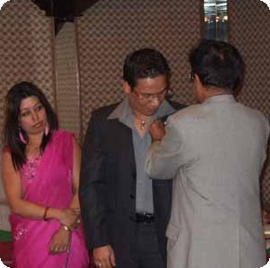
Mr Prakash Bajracharya, a new member of the Club, has become Rtn Prakash Bajracharya on 27 October 2006. He was inducted to the Club on that day at the Club meeting.
Congratulations ! Welcome to the Club.
PDG Kodi K Navada from Kolkata providing Rotary pin to Rtn Prakash on that occasion. His wife looks on.
On Lighter Side : Click at the figure ⇩
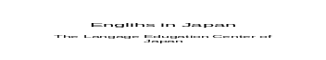

I ask you to Lead the Way by setting a personal example in your support of our Rotary Foundation. Without the Foundation, Rotary as we know it could not exist. It is up to us - all Rotarians - to ensure that the Foundation stays strong.
RI President William B. Boyd

3 November 2006 The Weekly Bulletin of Rotary Club of Kathmandu Mid-Town Bc # 18 of 2006-07

Editor: RR Shrestha, Club Service Director email: rryes@wlink.com.np

